**Instructions about DS-160 Application Form:**

**Filling out the DS 160:**

• Log onto <https://ceac.state.gov/genniv/> for the application. This link will be located on the consulate’s website and VFS’s website (WWW.VFS-USA.Co.in).

• Complete the DS-160 form as per following instructions.

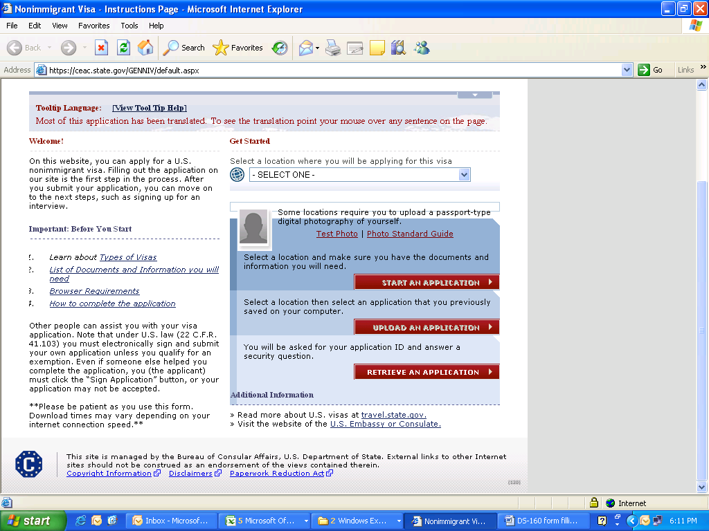

Once the location is Selected, Click here to **Start Application**

Select Consulate Location **India, Mumbai** Stamping for B1

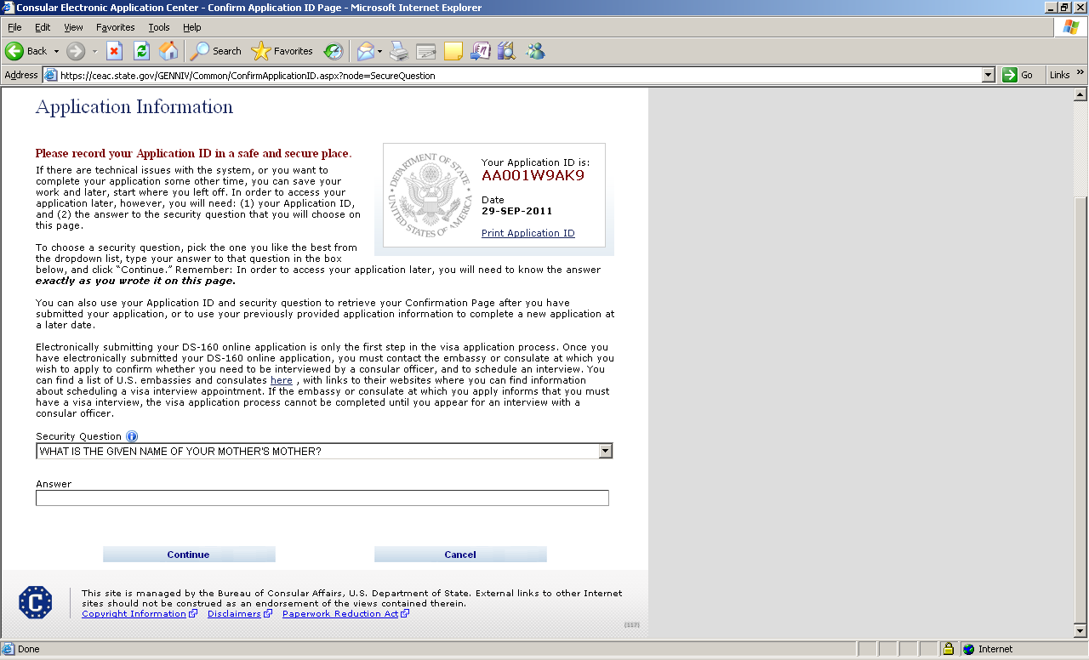

Answer the Security Question, and then click on Continue

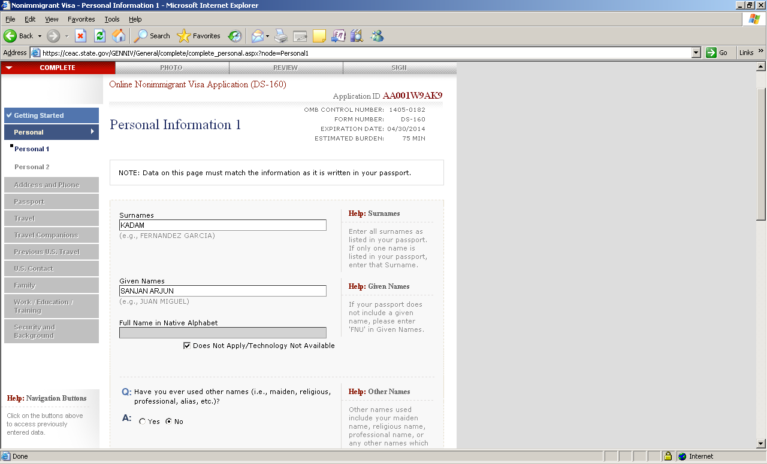

These details should be Similar as per applicant’s name on passport.

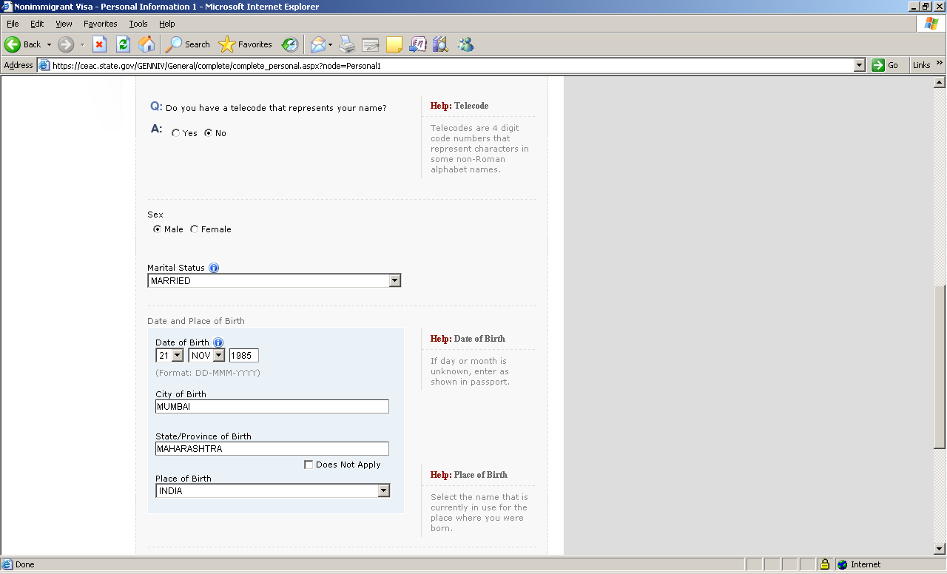

These details should be Similar as mentioned in the applicant’s Passport. Ma

Select **No**

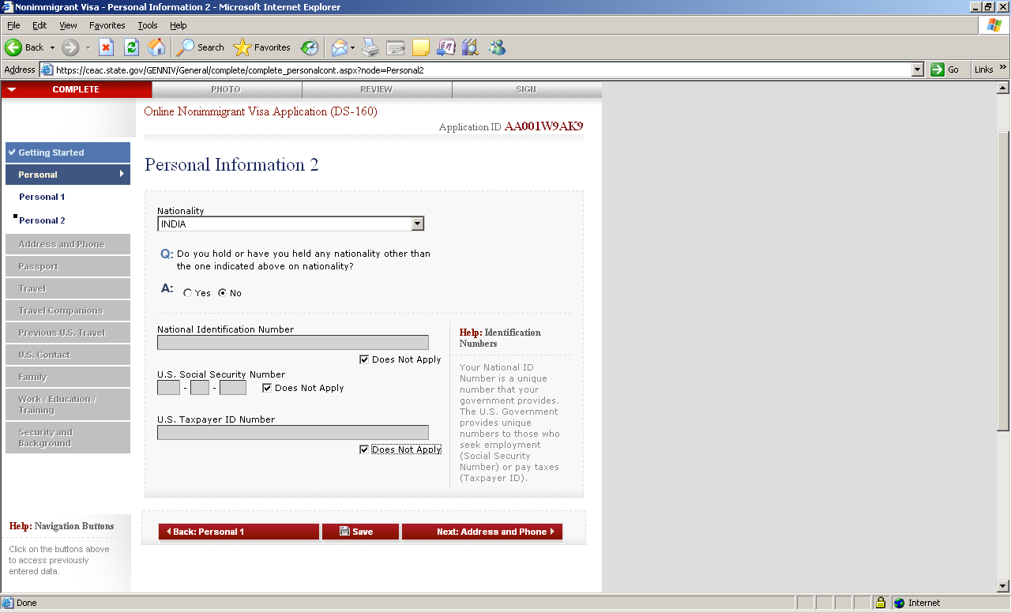

**Fill the details if applicable.**

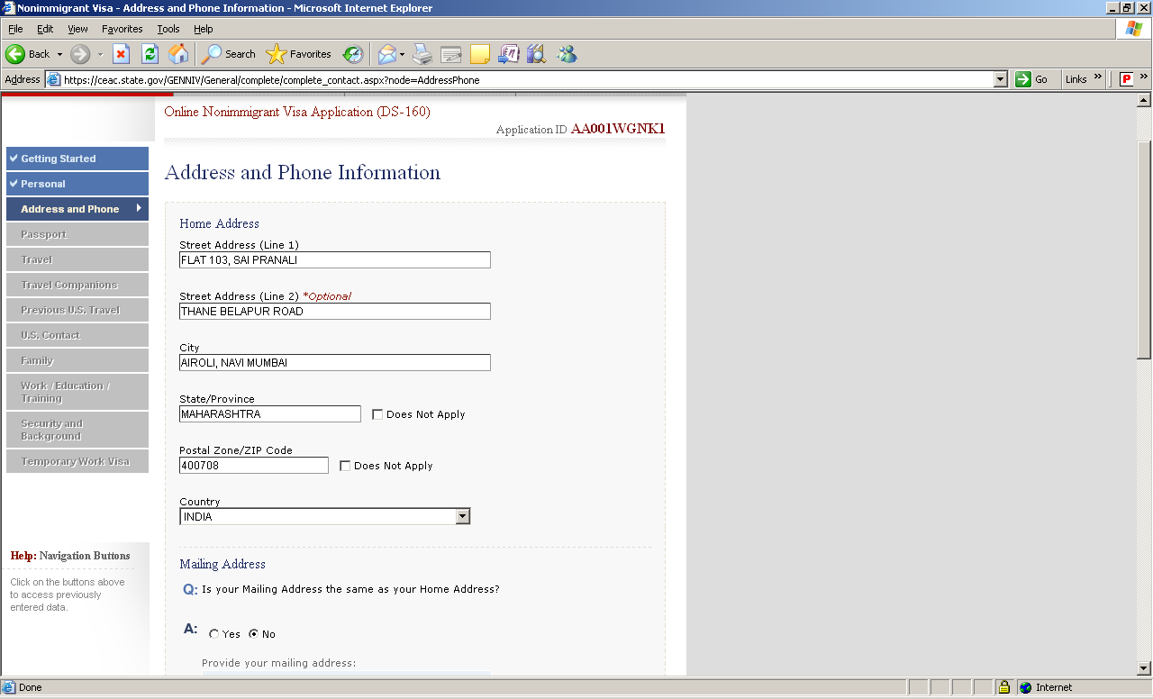

Mention the applicant’s Current (Pune) Residential address only.

Select “Yes”

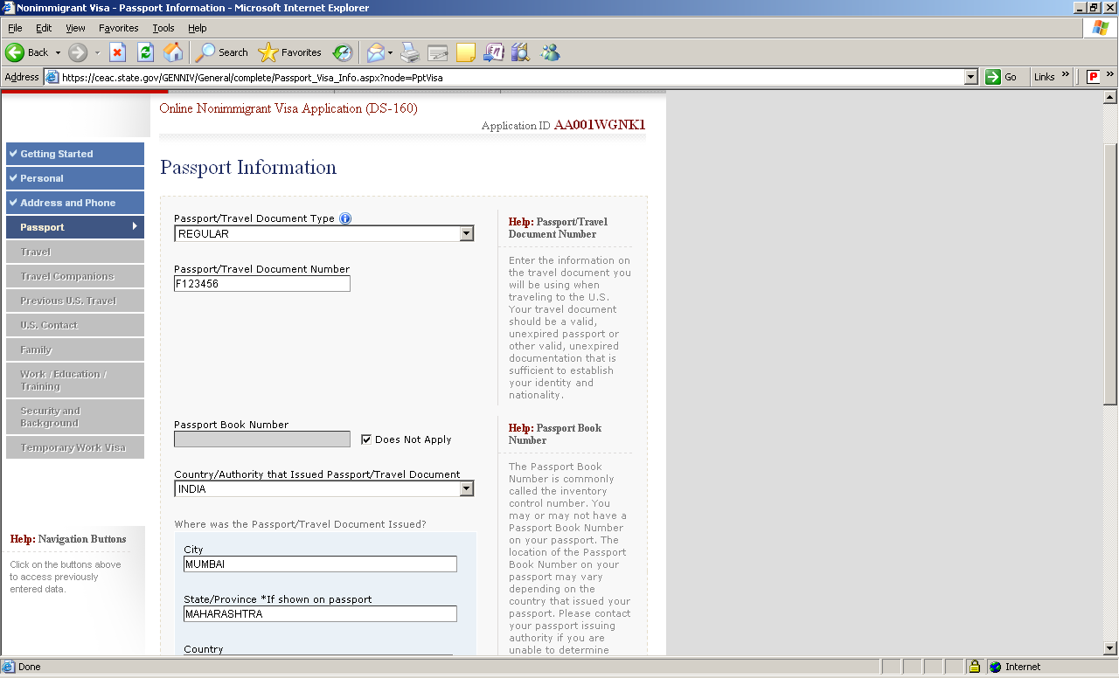

These details should be similar as mentioned in the applicant’s Passport

Select **Regular** & Mention Correct Passport Number

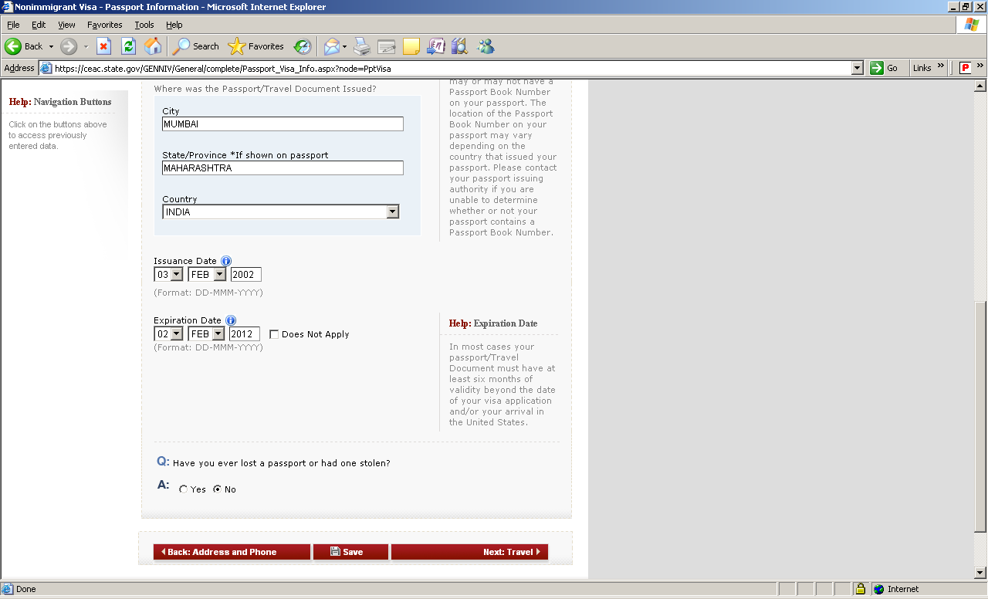

These details should be similar as mentioned in the applicant’s Passport

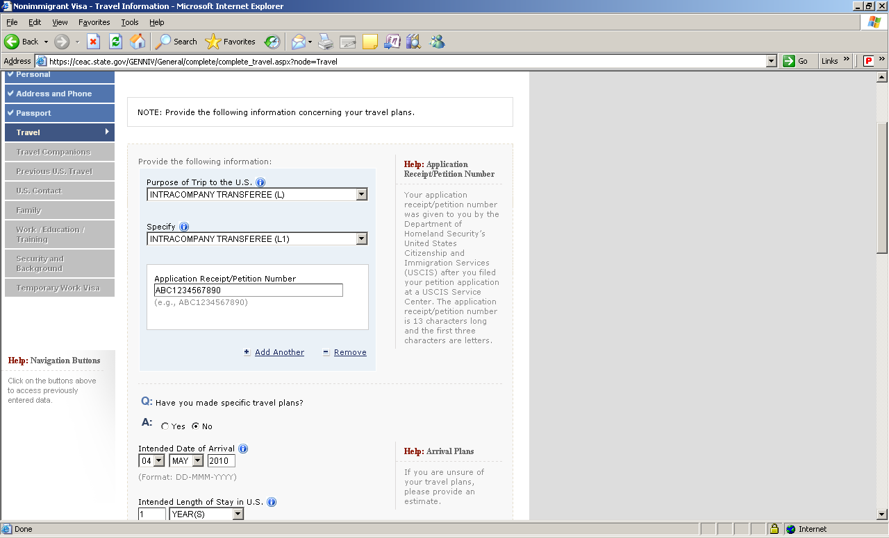

Mention date as per invitation letter.

Select:

“Temp. Business Pleasure Visitor (B) for **Business Visa**.

Select:

Business/Personal (B1)

Select **No**

Mention travel date as per invitation letter.

Mention your client address.

Select “Company /Organization”

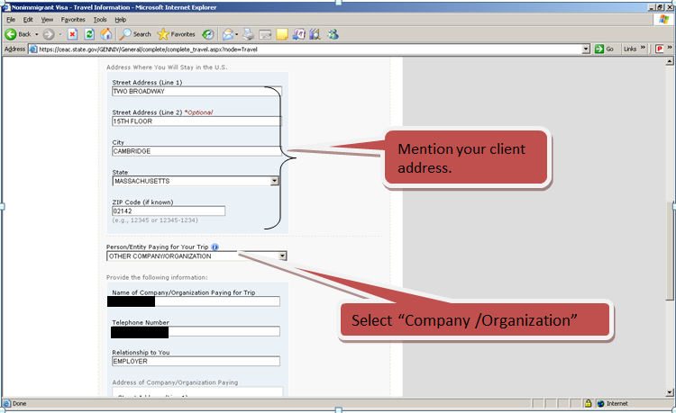

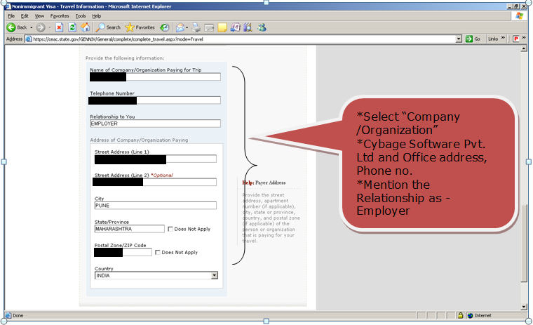

*Select “Company /Organization”

*Cybage Software Pvt. Ltd and Office address, Phone no.

*Mention the Relationship as -Employer

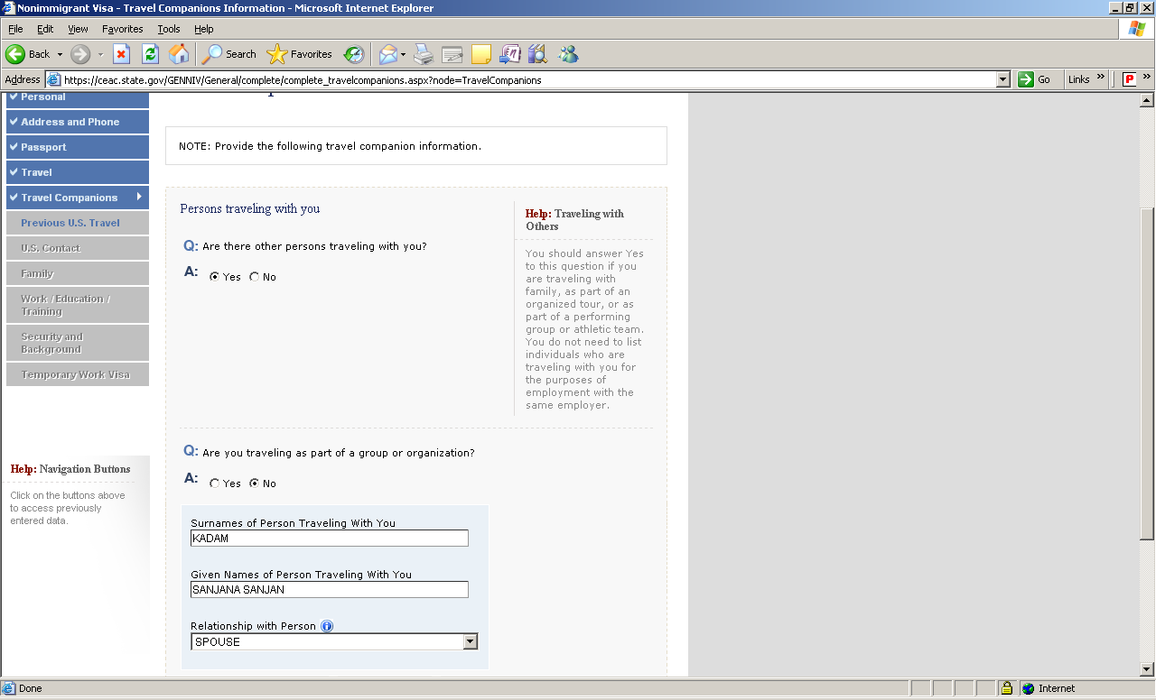

For B1 Select “No”.

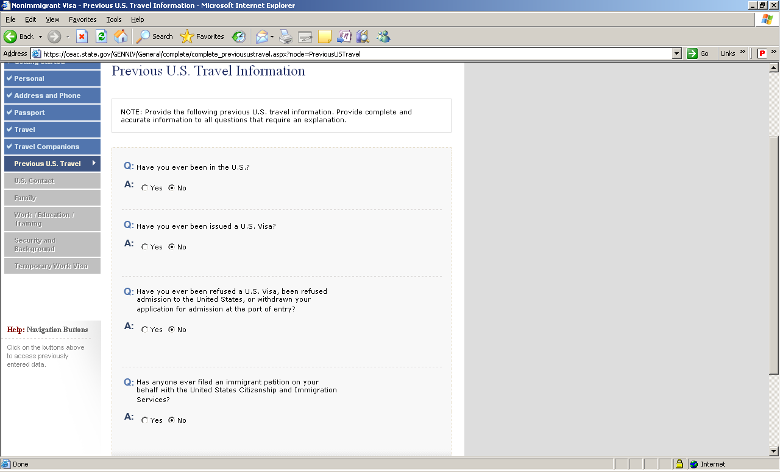

Select the alternatives as applicable.

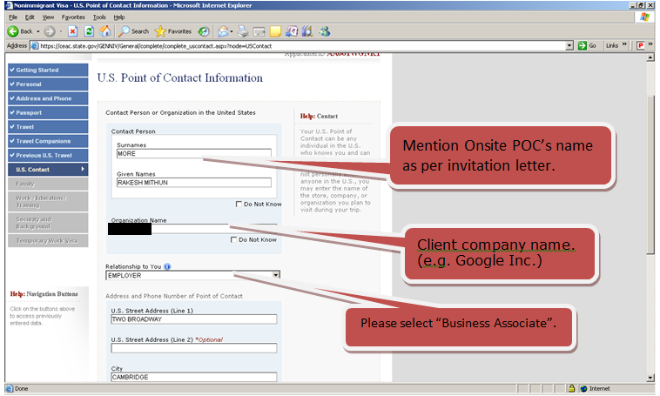

Please select “Business Associate”.

Client company name. (e.g. Google Inc.)

Mention Onsite POC’s name as per invitation letter.

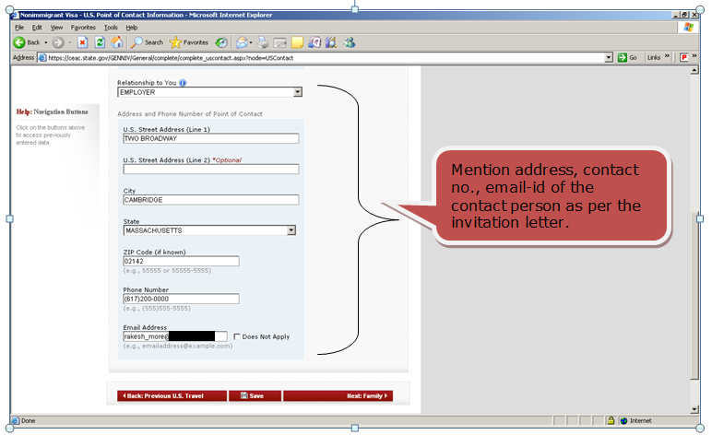

Mention address, contact no., email-id of the contact person as per the invitation letter.

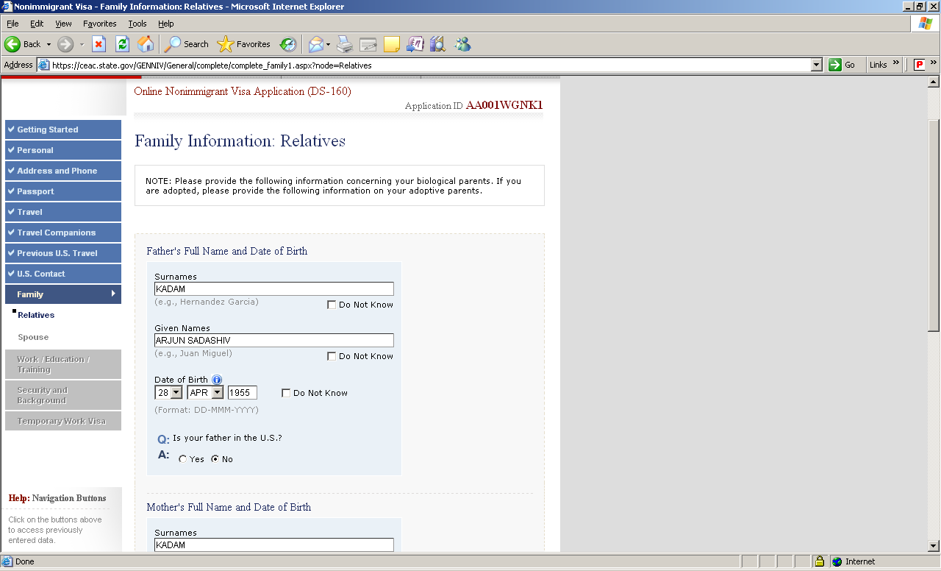

Mention the correct details.

Mention these details according to the Passport

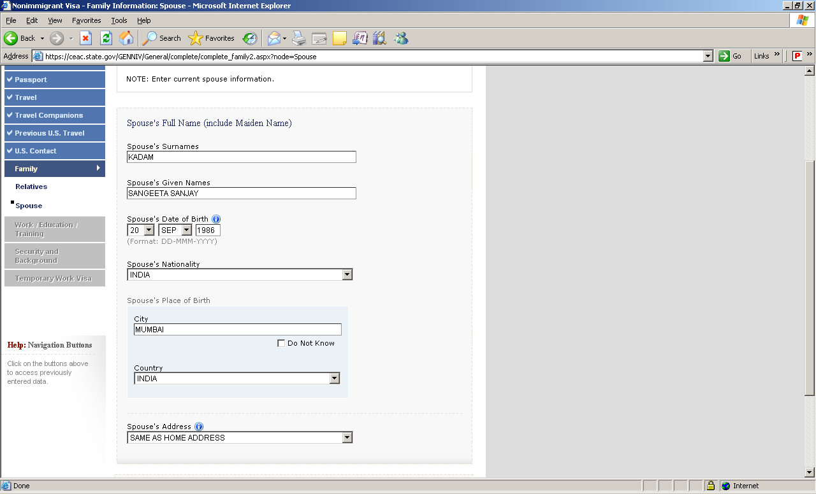

Mention Spouse details according to the Passport

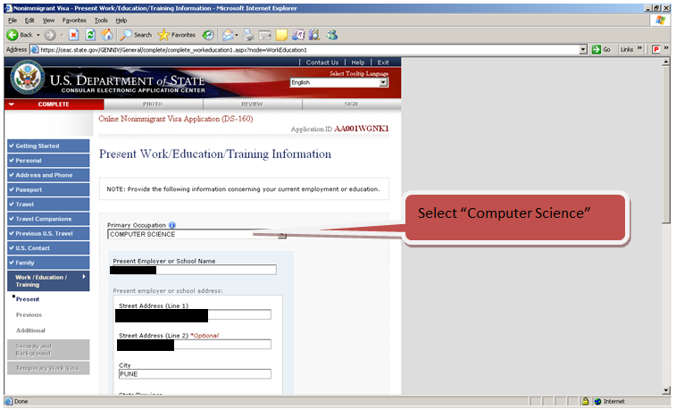

Select “Computer Science”

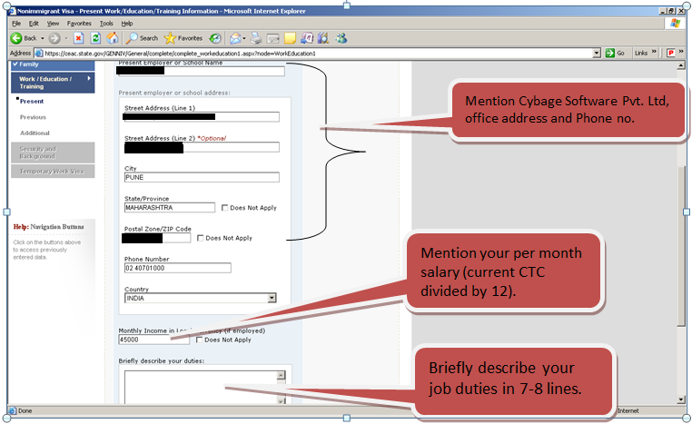

Briefly describe your job duties in 7-8 lines.

Mention your per month salary (current CTC divided by 12).

Mention Cybage Software Pvt. Ltd, office address and Phone no.

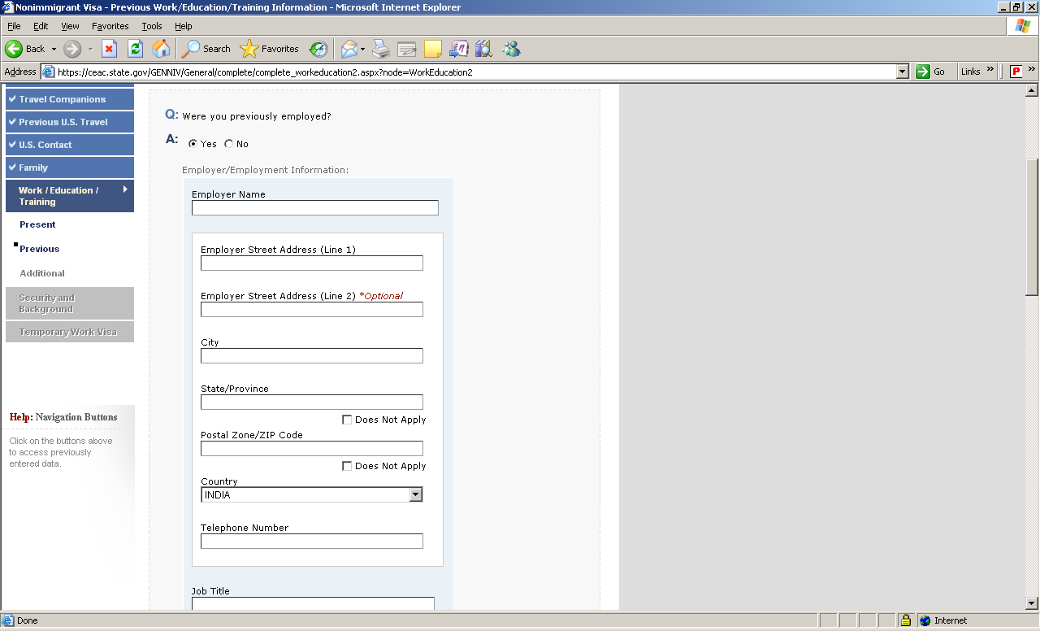

Select as applicable. If “YES”, request you to mention your previous employment details as asked below.

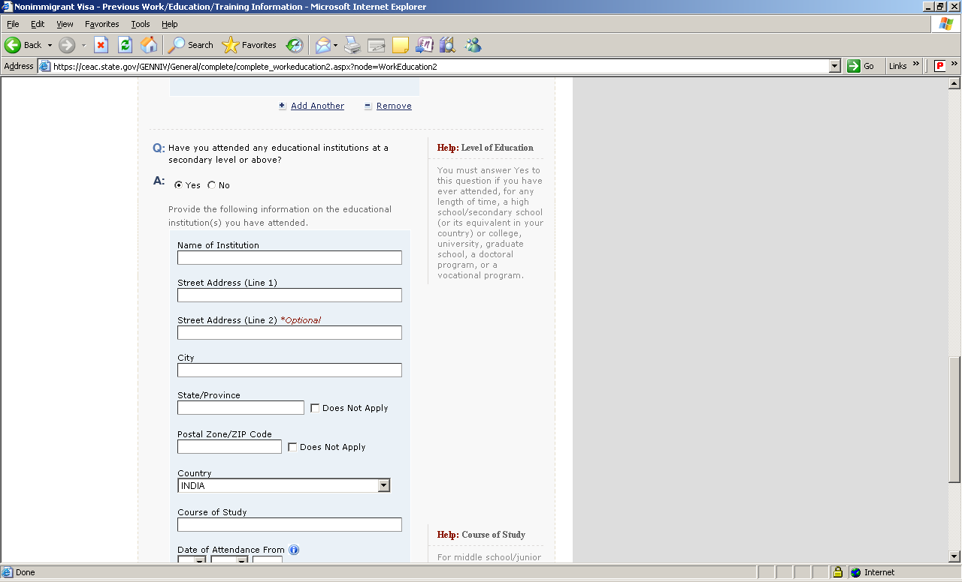

Select “YES” and mention your Educational Details. (**Starting from recent Degree/Diploma till 12th (HSC).**

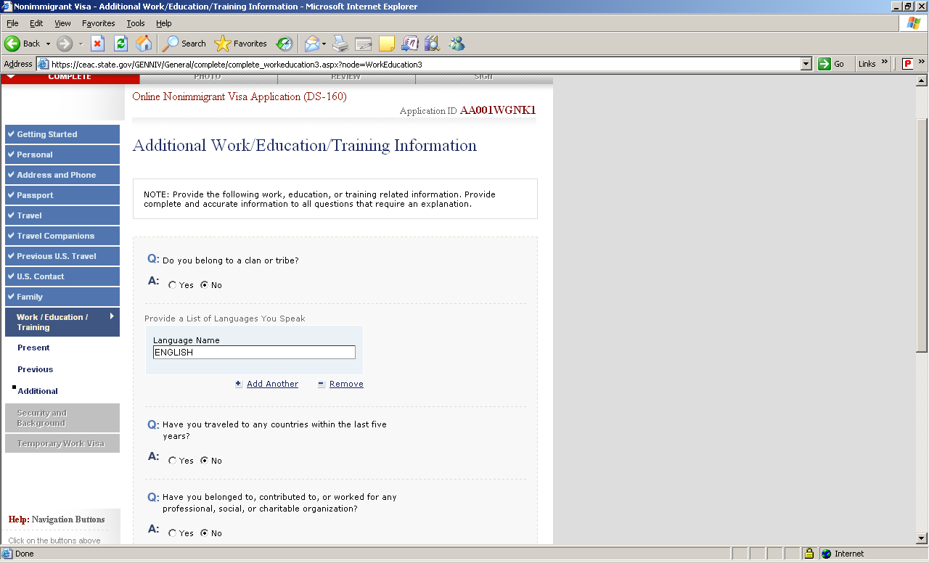

Provide a list of Languages you speak.

Select No

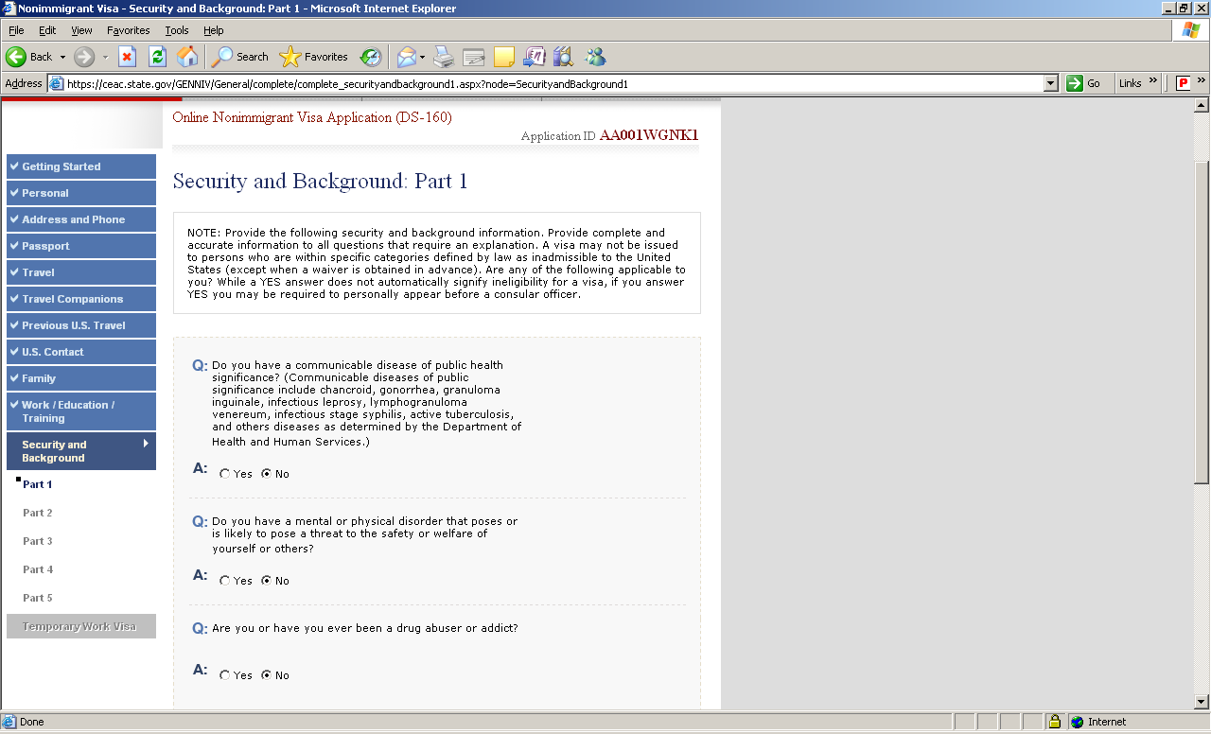

Select the alternatives as applicable

Get the salary details from ODC Team

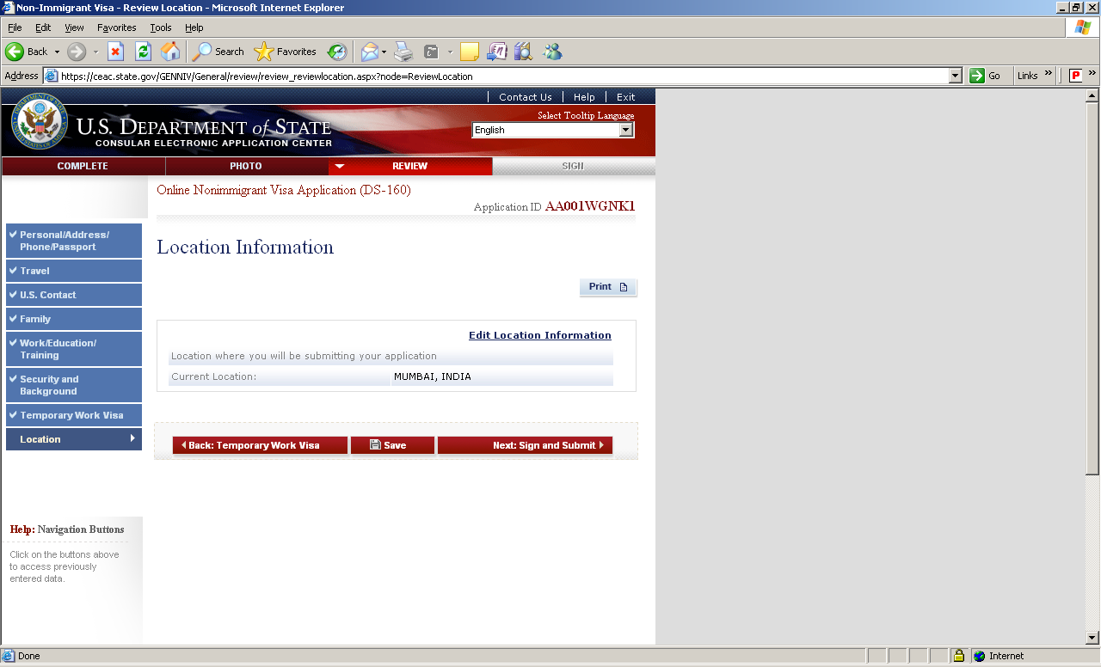

Click on “Save”, save the DAT. File and share it with Visa team.